|  |  |
| --- | --- |
| **Name** | Basmala Ahmed Mahdi |
| **Task** | Unit_25 (Task #2) |
| **School** | WE El-Mansoura |
| **Deadline** | 2 February 2025 |

**Introduction:**

This is a full web-based application for Dern-Support, an IT technical support company. The system is developed using SQL for database management, Laravel for backend, and React for frontend interface. The website has basic features like product listings, user authentication, and company information to optimize business operations and customer satisfaction.

**Programming Language:**

**Used SQL, PHP, HTML, CSS, JS & Frameworks: Laravel - React**  
  
**SQL:** To store database.

**Laravel:** Backend.

**React:** Frontend.

**Backend Files: Frontend Files:**

**Diagram of Website:**

**Home Section:**

**Contain a:**

* **Brand: Name of website (DERNSUPPORT).**
* **Links: Home page, Products page, About us page.**
* **Button: “Logout” Logout from website.**

**Our Products section:**

* **Contain some products that at website:**
* **Title of product.**
* **Description of product**
* **Price of product.**
* **Button to display product details.**

**Features section:**

* **Contain the features of company.**

**Why choose us section:**

* **Contain a advantages of company.**

**Footer section:**

* **Contain:**
* **Pages at website.**
* **Contact information.**
* **Social Media Links.**

**Products Page:**

* **Contain:**
* **Input and button Search to search about product.**
* **All Product and Button Detail of Product.**

**About Page:**

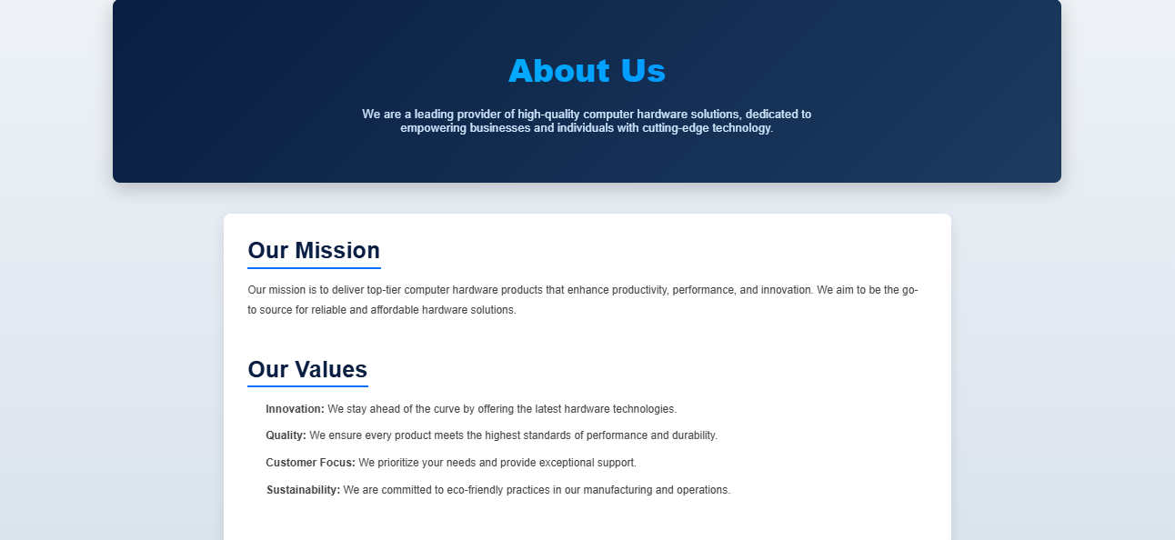

* **Contain a information about company.**

**Login Page:**

* **Contain:**
* **Email & Password input to enter your email & Password.**
* **Login button to login to website.**
* **Sign-up link to go Register page if user not have an account.**

**Register page:**

* **Contain:**
* **Username input.**
* **Email input.**
* **Password “At least 8 characters”.**
* **Confirm Password “Match the Password”.**
* **Login link if user already have account.**

**Testing:**

After Solving Errors, The Program work well.

**Feedback (Classmate):**

Professional program as it contains all requirements.

**Conclusion:**

The completed web application well serves the needs of Dern-Support through having a user-friendly interface, secure login, and efficient product management. The solution has been refined to ensure reliability and performance through test and feedback. Enhancements in the future can include additional features and optimizations to enhance user experience further.